ZENMAP:- HOST

Zenmap is the Nmap security scanner graphical user interface and provides for hundreds of options. It lets users do things like **save scans and compare them, view network topology maps, view displays of ports running on a host or all hosts on a network, and store scans in a searchable database**.

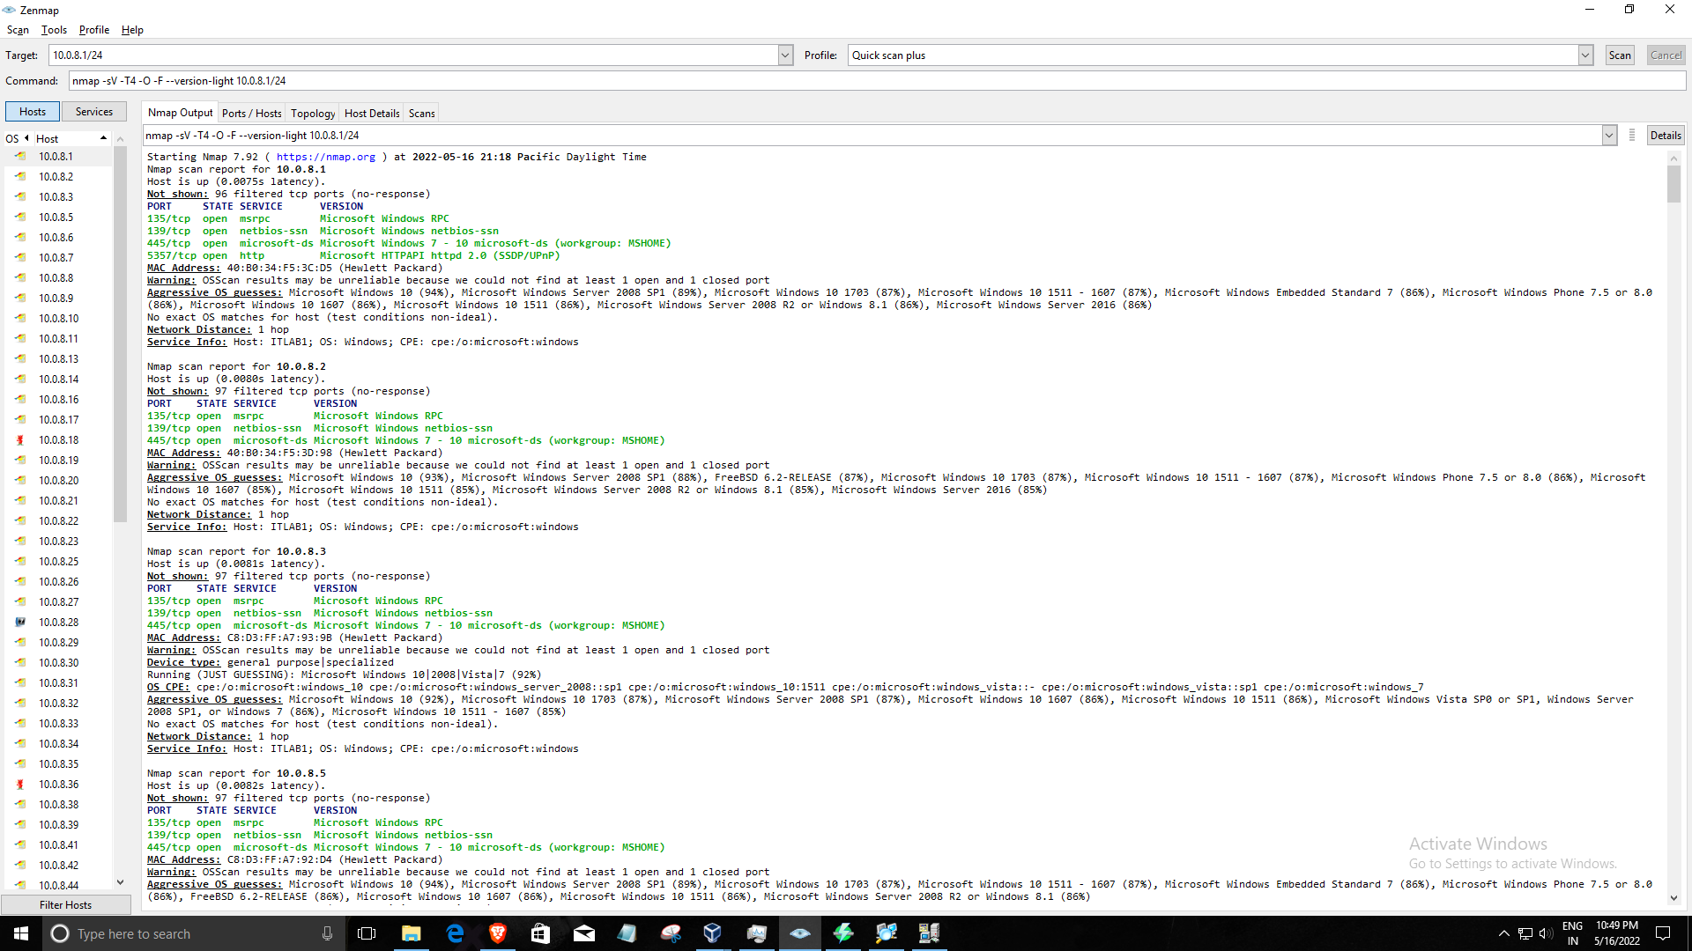

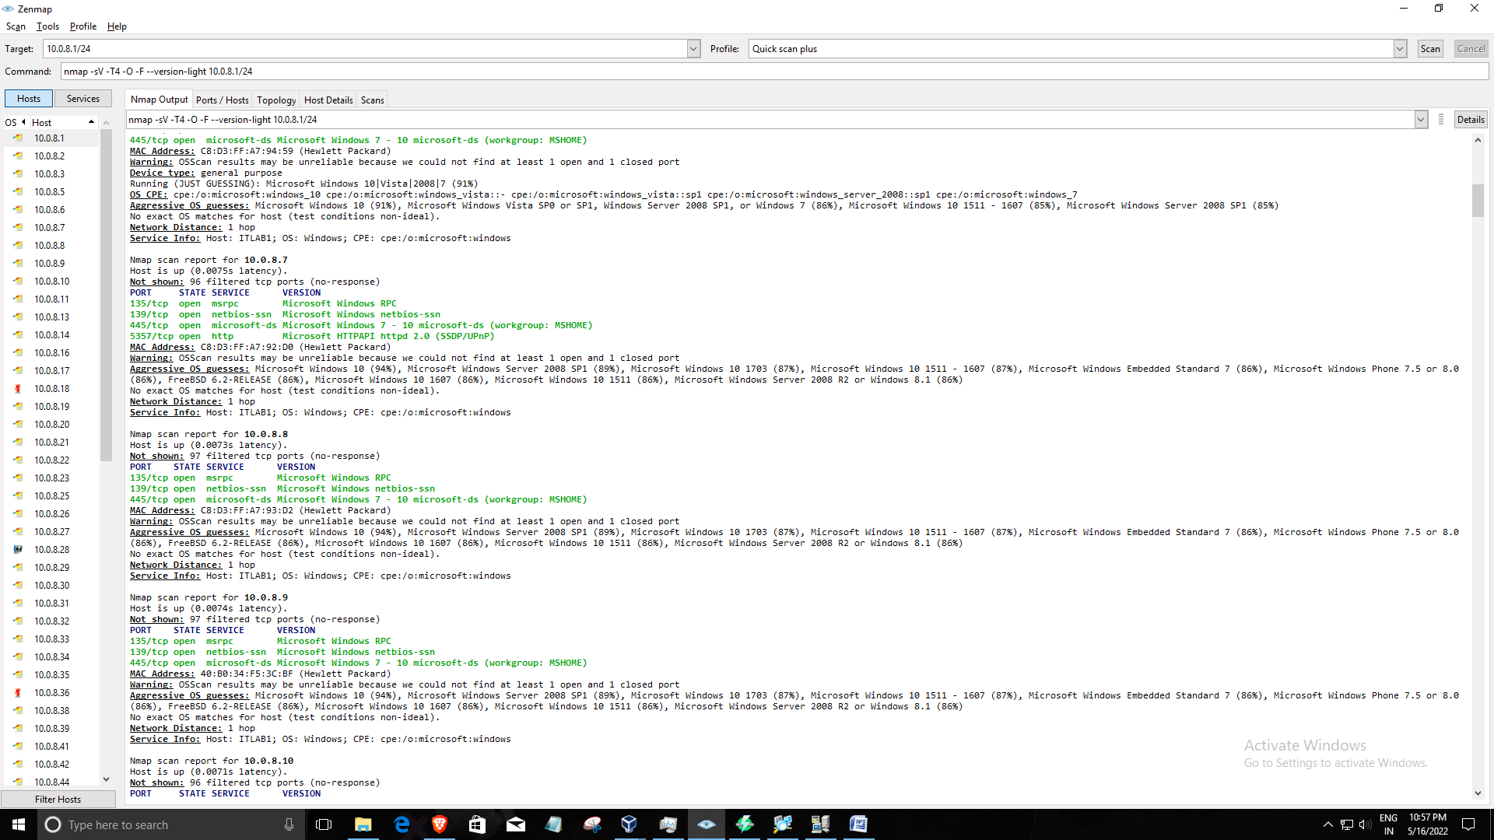

TOPOLOGY:-

Network topology refers to the manner in which the links and nodes of a network are arranged to relate to each other. Topologies are categorized as either physical network topology, which is the physical signal transmission medium, or logical network topology, which refers to the manner in which data travels through the network between devices, independent of physical connection of the devices. Logical network topology examples include twisted pair Ethernet, which is categorized as a logical bus topology, and token ring, which is categorized as a logical ring topology.

Physical network topology examples include star, mesh, tree, ring, point-to-point, circular, hybrid, and bus topology networks, each consisting of different configurations of nodes and links. The ideal network topology depends on each business’s size, scale, goals, and budget. A network topology diagram helps visualize the communicating devices, which are modeled as nodes, and the connections between the devices, which are modeled as links between the nodes.

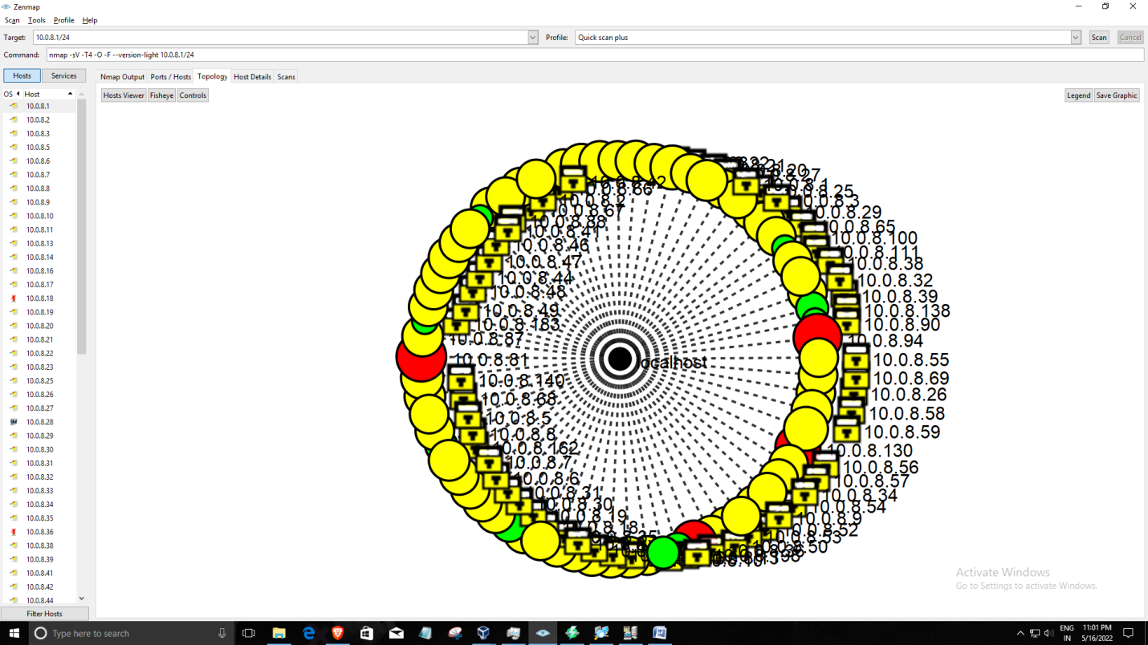

ANGRY IP SCANNER:-

Angry IP Scanner (or simply ipscan) is an open-source and cross-platform network scanner designed to be fast and simple to use. It **scans IP addresses and ports as well as has many other features**.

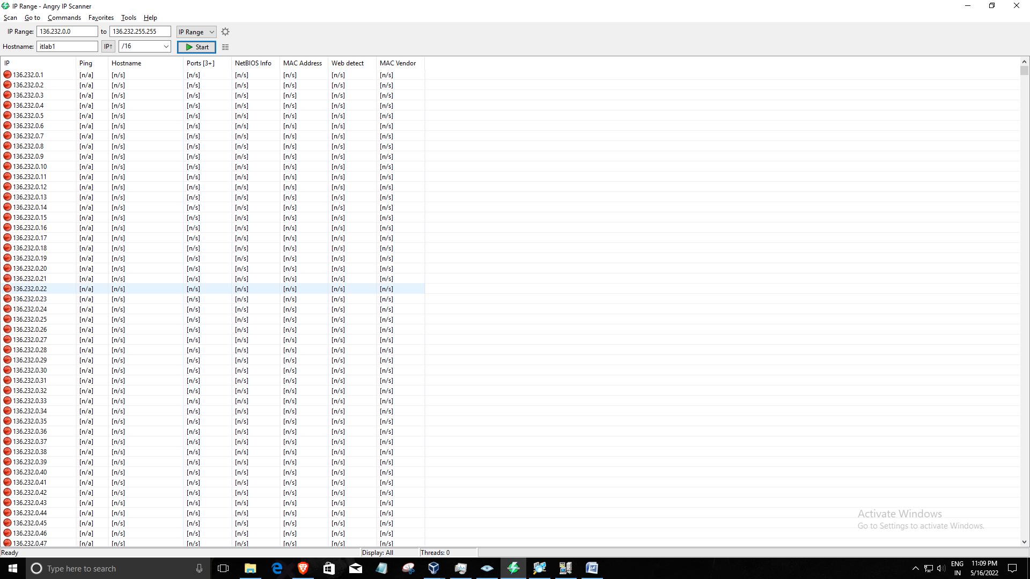

OUTPUT:-

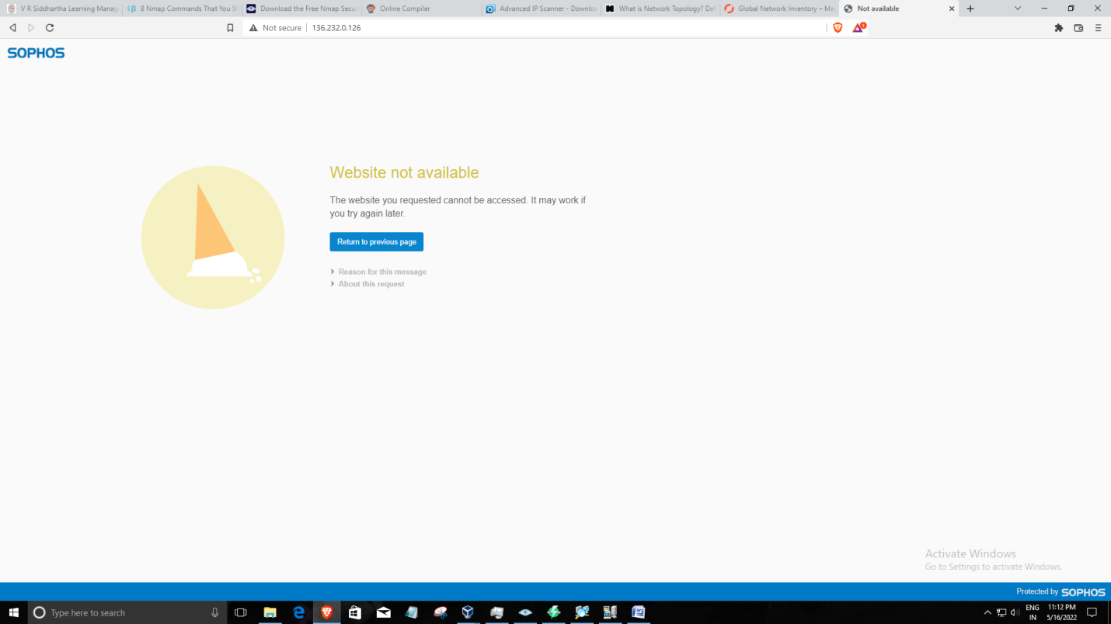

PORTS:

A port is a virtual point where network connections start and end. Ports are software-based and managed by a computer's operating system. Each port is associated with a specific process or service. Ports allow computers to easily differentiate between different kinds of traffic: emails go to a different port than webpages, for instance, even though both reach a computer over the same Internet connection.

SERVICES:

In computer networking, a **network service** is an application running at the network [application layer](https://en.wikipedia.org/wiki/Application-Layer_Protocol_Negotiation) and above, that provides data storage, manipulation, presentation, communication or other capability which is often implemented using a [client–server](https://en.wikipedia.org/wiki/Client%E2%80%93server_model) or [peer-to-peer](https://en.wikipedia.org/wiki/Peer-to-peer) architecture based on application layer [network protocols](https://en.wikipedia.org/wiki/Communication_protocol).[[1]](https://en.wikipedia.org/wiki/Network_service#cite_note-SDxCentral,_2015-1)

Each service is usually provided by a [server component](https://en.wikipedia.org/wiki/Server_(computing)) running on one or more computers (often a dedicated server computer offering multiple services) and accessed via a network by [client components](https://en.wikipedia.org/wiki/Client_(computing)) running on other devices. However, the client and server components can both be run on the same machine.

Clients and servers will often have a [user interface](https://en.wikipedia.org/wiki/User_interface), and sometimes other hardware associated with it.

IP ADDRESS:

An [IP](https://www.javatpoint.com/ip-full-form) address is the identifier that enables your device to send or receive data packets across the internet. It holds information related to your location and therefore making devices available for two-way communication. The internet requires a process to distinguish between different networks, routers, and websites. Therefore, IP addresses provide the mechanism of doing so, and it forms an indispensable part in the working of the internet. You will notice that most of the IP addresses are essentially numerical. Still, as the world is witnessing a colossal growth of network users, the network developers had to add letters and some addresses as internet usage grows.

ADVANCED IP SCANNER:

Advanced IP Scanner is **fast and free software for network scanning**. It will allow you to quickly detect all network computers and obtain access to them. With a single click, you can turn a remote PC on and off, connect to it via Radmin, and much more.

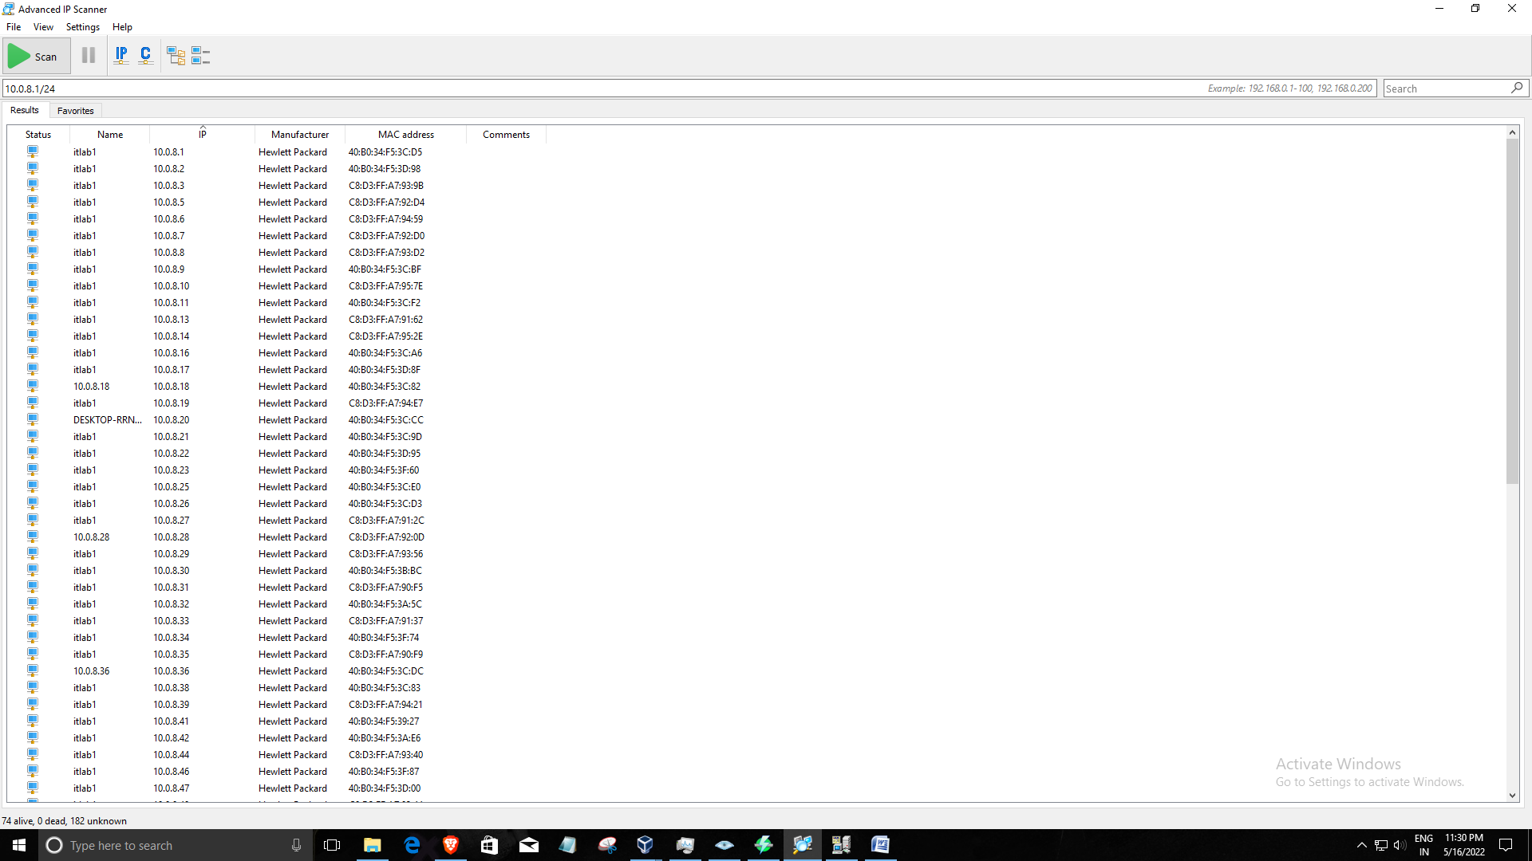

208W1A1277- HEMAN SAI CH